Worksheet 1

Student Name:Sarvesh yadav UID:25IMC13002
Branch: UIC Section/Group:25MAM-3(B)
Semester: 2 Date of Performance:15/01/2026
Subject Name: Machine Learning Subject Code: 25CAP-672

Experiment 1
Aim:
Introductions of Python Basic Libraries:Math, NumPy, Matplotlib, Seaborn, SciPy and Python setup
-Step-by-Step.
a. Math
b. NumPy
c. Matplotlib
d. Seaborn
e. SciPy.

2. Apparatus:

Supported Operating Systems:
- Windows 10 64-bit Pro
Programming Language:
- Python
Development Environment:
- Jupyter

3. Coding :
a)
#math
import math
a=math.sqrt(16)
print(a)
b=math.pow(10,2)
print(b)

output-
4.0
100.0
b)
# numpy
import numpy as np
d=np.array([5,8,10])
print(d+10)
c=np.arange(1,10)
print(c)
print(c.reshape(3,3))

output-
[15 18 20]
[1 2 3 4 5 6 7 8 9]
[[1 2 3]
[4 5 6]
[7 8 9]]
c)

#matplot
import matplotlib.pyplot as plt
a=[1,2,3,4]
b=[10,20,30,40]
plt.plot(a,b)
plt.show()

output-
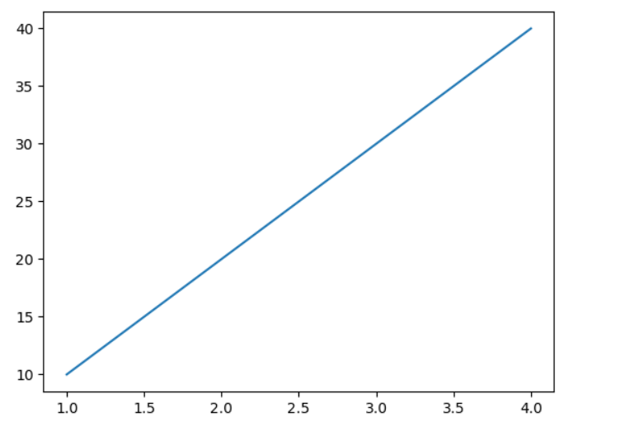

d)

import seaborn as sns
import matplotlib.pyplot as plt
import numpy as np
a=np.random.randint(1,10,9).reshape(3,3)
sns.heatmap(a)
plt.show()

output-
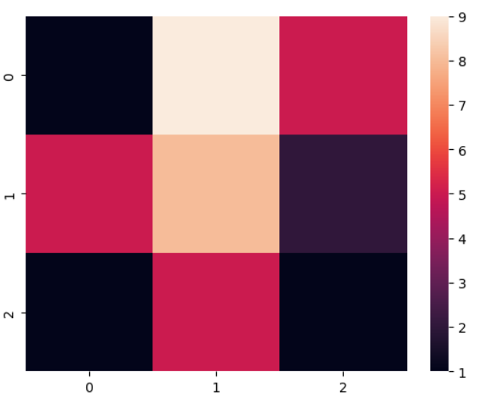
e)

# scipy
from scipy import optimize
def f(x):
return (x - 2)**2 + 1
res = optimize.minimize(f, x0=0)
print("x at minimum:", res.x)
print("minimum value:", res.fun)

output-
x at minimum: [1.99999997]
minimum value: 1.0000000000000007
Experiment – 2
Aim-

1) Creation and loading different Datasets in Python using Jupyter Notebook. Write a program to implement Linear regression on
a Jupyter notebook.
a. Download different datasets from Kaggle or UCI
ML repository.
b. Import all the necessary modules for the datasets.
c. Find out the best fit line along with the MSE, RMSE.

import numpy as np
import pandas as pd
import matplotlib.pyplot as plt
from sklearn.model_selection import train_test_split
from sklearn.linear_model import LinearRegression
from sklearn.metrics import mean_squared_error
# Load dataset
data = pd.read_csv("C:\\Users\\Sarvesh Yadav\\Downloads\\Advertising.csv")
# Features and Target
X = data[['TV']]
y = data['Sales']
# Train-test split
X_train, X_test, y_train, y_test = train_test_split(
X, y, test_size=0.2, random_state=42
)
# Create and train model
model = LinearRegression()
model.fit(X_train, y_train)
# Predictions
y_pred = model.predict(X_test)
# Plot
plt.figure(figsize=(8, 6))
plt.scatter(X_test, y_test, color='blue', label='Actual Data')
plt.plot(X_test, y_pred, color='red', linewidth=2, label='Best Fit Line')
plt.xlabel('TV Advertising Budget')
plt.ylabel('Sales')
plt.title('Linear Regression - Best Fit Line')
plt.legend()
plt.show()
# Mean Squared Error
mse = mean_squared_error(y_test, y_pred)
# Root Mean Squared Error
rmse = np.sqrt(mse)
print("Mean Squared Error (MSE):", mse)
print("Root Mean Squared Error (RMSE):", rmse)

output-
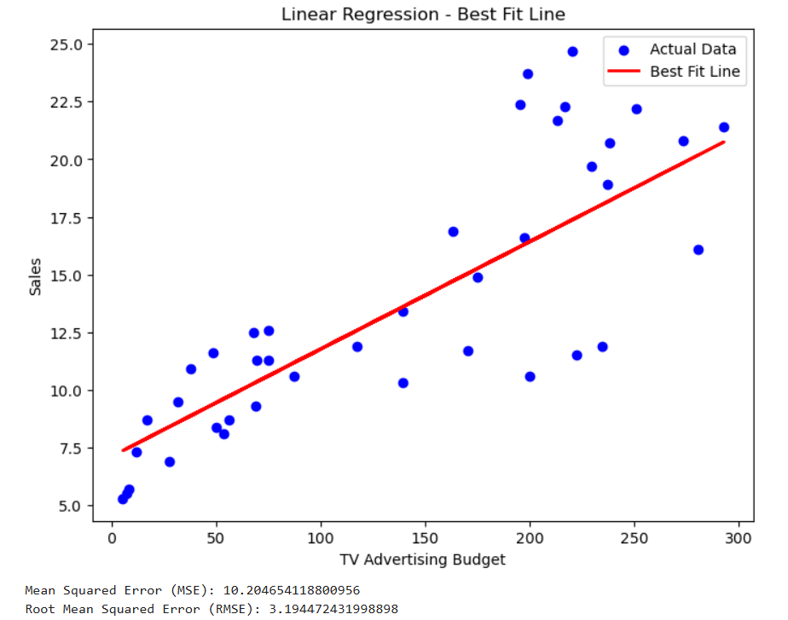

5. Learning outcomes (What I have learnt):
- I learned how to install and set up Python and Jupyter Notebook and use basic Python libraries required for Machine Learning.
- I understood the usage of core Python libraries such as Math, NumPy, Matplotlib, Seaborn, and SciPy for mathematical operations, data handling, visualization, and optimization.
- I learned how to load and work with real-world datasets using Pandas and perform basic data preprocessing tasks.
- I understood the implementation of Linear Regression, including model training, plotting the best fit line, and evaluating performance using MSE and RMSE.

